1. Enter project Details
2. Enter Epic
3. (Go on project settings and click on features and enable all features like deployments and all we will get versions feils from their)
4. Enter versions.
5. Enter User stories to Backlog
6. Drag User stories to that’s epics-(When u will click on epics like browser what are there is browser will show)
7. Drag user stories to respective versions(when u will click on version what are the user features are in versons)
8. 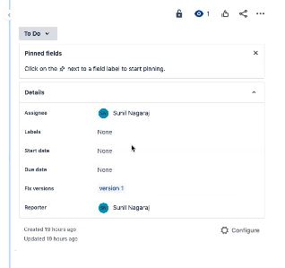Click on epic Browser and click on all details it will show u on right side click on right click open in a new tab
9. Assign to some one
10. Click on configure and add the configures add like priorities etc..
11. 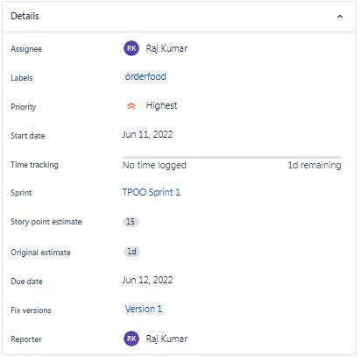
12. Enter Work log time for anything user stories and epics etc
13. Preioreties setting
14. Click on version 1 and drag all the version 1 things to sprint 1.
15. Once after adding user stories to sprints we cannot modify. User stories
16. Start Sprint 1. Add description and click on start – after clicking on start we will go to kanban

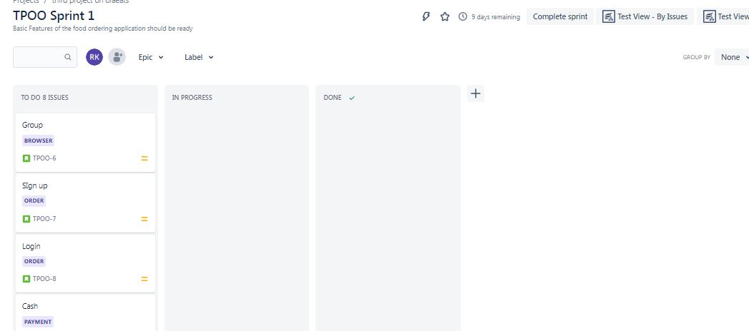

1. Add fields like Developer, Testing,Diployment
2. Drag the user stories to all fields upto done
3. Once done click on complete sprint 1.
4. 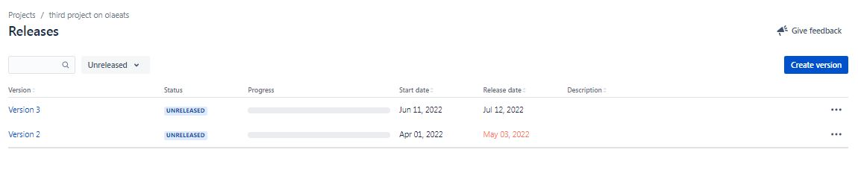Click on Release and Release version one
5. By clicking on Release un Release we can see everything what released how many are there etc
6. Same by clicking on version 2 drag and put it in Sprint 2 strt sprint
7. And same like above kanban develop,test, diploy, done and release
8. Story estimate- Time taken complete all stories
9. Story Point estime –Time taken complete 1stories
10. Then he said about Reports
11. Now we are discussing about how to assign task, sub task, child task
12. Developer develop the Search by filters and debit card and testers test the thing
13. Click on add a child issue
14. Addsub task like I have developed the software now test the sw. and we will assign anyone
15. Now go for start sprint 2
16. GO to board and the things in todo and develop and testing
17. Now on top click on create and create a Bug and summary
18. Select version and select issue like block
19. Select issue type like subtask what u have added 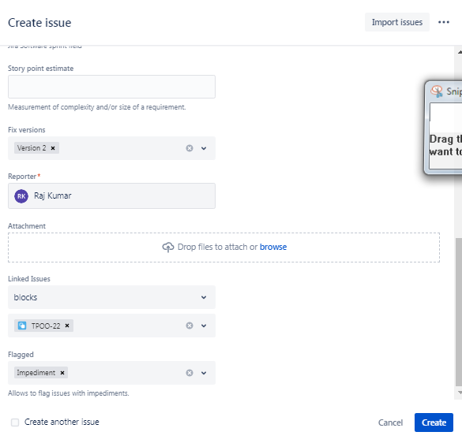 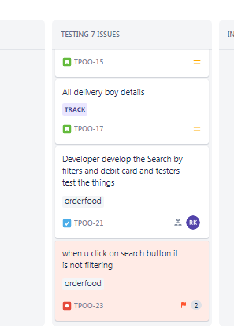
20. Now we are pluggin the Zephard square
21. Add Zephard squard to jeera
22. Add a task to Sprint 3 and start sprint 3 and drag everything in Testing.
23. Now go and create a issue type go to Project settings and click on issue types ( there are 5 types of issue types Epic,bug,subtask,userstory,bug).
24. 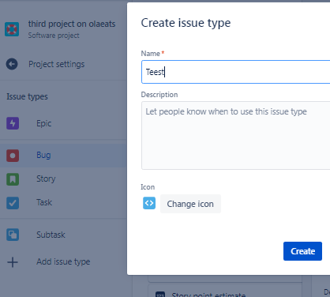
25. GO back to project settings click on zephyd squade and select issue type
26. 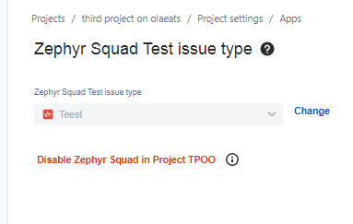And enable it next..next..next
27. Go back to project and on Report
28. We will go on Board and create a issue type Teest 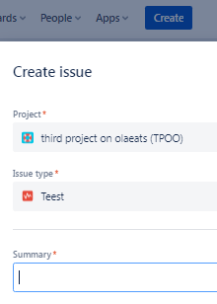
29. Go to backlog add it to sprint 3 – Go to Board- add to testing 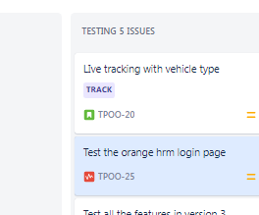
30. Click on orangehm login—Add description—add test cycles.—click on zephyr squad
31. Go on add cycle summary 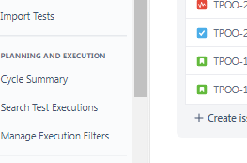
32. Create new test cycle 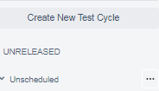
33. Type Regression testing and create once added go back to board
34. Click on test the login page of hm orange Teest add test cyclces
35. Add Test Cycles
36. Click on right side … 3dots and select execute 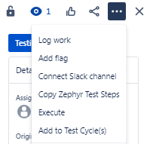
37. 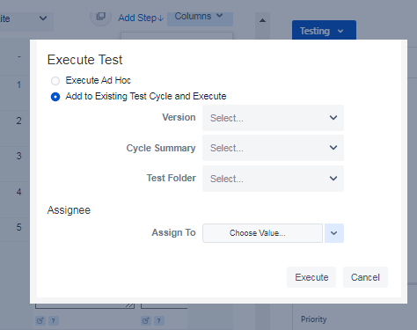
38. Add verion, cycle summery, assign. And click on execute
39. Click on pass and comments 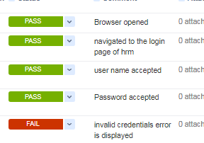
40. Create a new defect 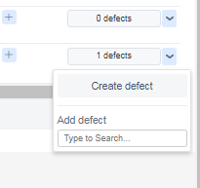
41. Click on done 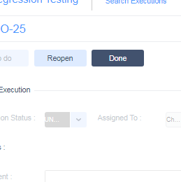
42. Click on reopen and give as pass and click on defect. Click on it and go to that page
43. Click on done and over all execution status is pass now
44. Once after done everything go project and zypher squade.
45. 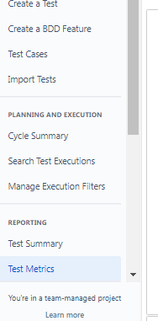 Click on test execution 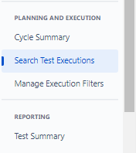
46. And click on test summary.. and all those things like test matrics, test summaries all those reports.